**Engineering applications write up**

# Intro: -

This project has been about giving us the ability to solder acceptable joints, to solder wire to a circuit-board without melting the insulation, and how to design a PCB using the Proteus software provided to us by the university. To test us on our abilities and to help us develop our still raw, hot off the press, skillset, we were given a specific and suitable task to preform over this two-week period.

During this project, to start with, I was given the task to solder the tips of wires together to make a cubic shape. This was to practice my soldering joints, so they can be as clean and acceptable as possible before I moved onto the next task.

This included soldering a strip board with straight lines of insulated wire. Trying to prevent any solder joints from ‘short circuiting’ in a sense. All the way down each row of the board, each strips of wire had reduced and increased in length with each increment. I did this until the board had been coated in a series of insulated wires, flush to the board, in a beeline.

After I had completed this task, I had to then design a pair of circuit boards using the Proteus software. Which allowed me to draw out the circuit and to then put the components and connections into the Proteus PCB designer. The PCB designer allowed me to arrange the components and to connect them together with tracks in any possible way that I sought, or the arrangement of the components would allow of me.

After this was done, I would then be able to use a 3D modelling feature to render the circuit board in a 3D environment, where I could observe it, the tracks and the placement of the components.

Another feature that the Proteus software allowed me to do is to create a component list, that allowed me to write the stock numbers and the prices for each, individual component on the list. This was done to allow me to print off a suitable list of components and where to get them. So, when I hand the technicians this list, they could easily find the requested components and know which supplier to get them from.

With the soldering test out of the way and the designing of the boards completed, I can now focus my attention on the soldering of the already printed pair of PCB boards. The Encoder and the Decoder. While soldering these two boards, I would need to make sure that the solder joints were of an acceptable and clean quality.

I would then finish this project off by applying a power source to both circuits and testing that both circuits preform as intended.

My aims for this project are as follows…

* To learn how to produce a clean and acceptable solder joint
* To be able to solder multiple insulated wires together
* To be able to solder insulated wires flush to a strip board
* To be able to learn how to properly clean the soldering iron before use
* To learn how to create a circuit design in Proteus
* To learn how to design a PCB circuit in Proteus
* To learn how to create a list of components ready to be purchased by a supplier

My objectives for this project area as follows…

* To create a cube using strips of wire and soldering them together
* To solder strips of insulated wire, flush to a strip board
* To design the Encoder and Decoder circuit in Proteus
* To design the Encoder and Decoder PCB in Proteus
* To render the Encoder and Decoder PCB in Proteus
* To create a list of components that include the price and stock ID for each component for the Encoder and Decoder PCB’s
* To solder the components to the Encoder and Decoder PCB
* To test the pair of Encoder and Decoder circuit boards, to ensure that they function properly.

# Design: -

The schematics were created using the designing program called ‘Proteus’. Proteus allows me to be able to select a series of components, from a library built into the program and place them in a virtual 2D environment. Which I can then use to manipulate and arrange each component in any way I please. After I have finished placing the components and positioning them I was able to use the connection tool to draw a track between two or more pins/terminals.

I was not able to find all the components that I needed for each circuit, so I had to utilise the tools that Proteus provides for me to make my own components and add them to the library. The program allows me to do this by drawing a square box of any shape, but of a suitable size and applying the correct number of terminals to it for my specific component. After the terminals had been applied, I labelled each pin with an identifying name and pin number. Selecting the whole new component and right clicking it, allowed me to select the option to create the component; where I would give the device a name and a reference prefix. The program would then ask me for a footprint for the device; which I could either select an already existing one from the library or I would be able to create an entirely new one later in the process; which I will explain later in this report. After finalising the process, I had to then delete the design for the component that was still in my schematics layout page and search the library for the newly created one. Which I was able to select and place down into my layout. This is because the layout for the component still had individual objects that made it up, but the newly placed one was treated as a new, single object.

Decoder

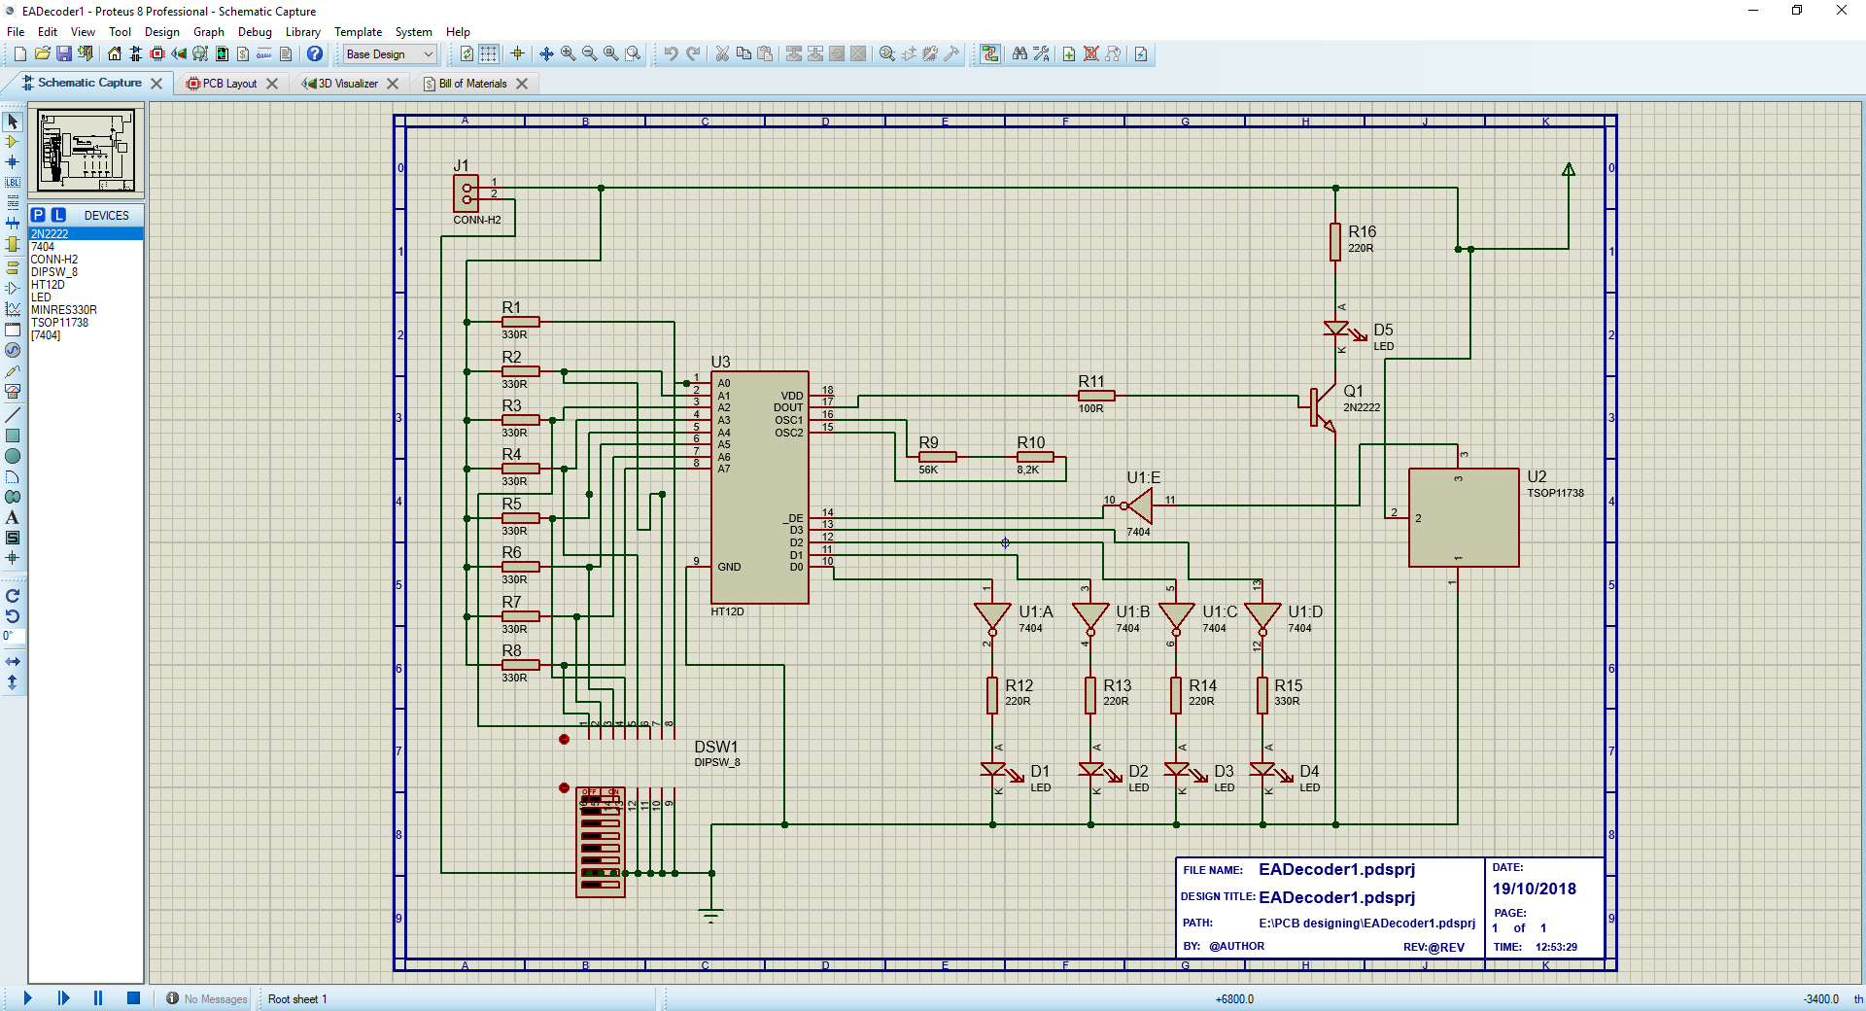

Encoder

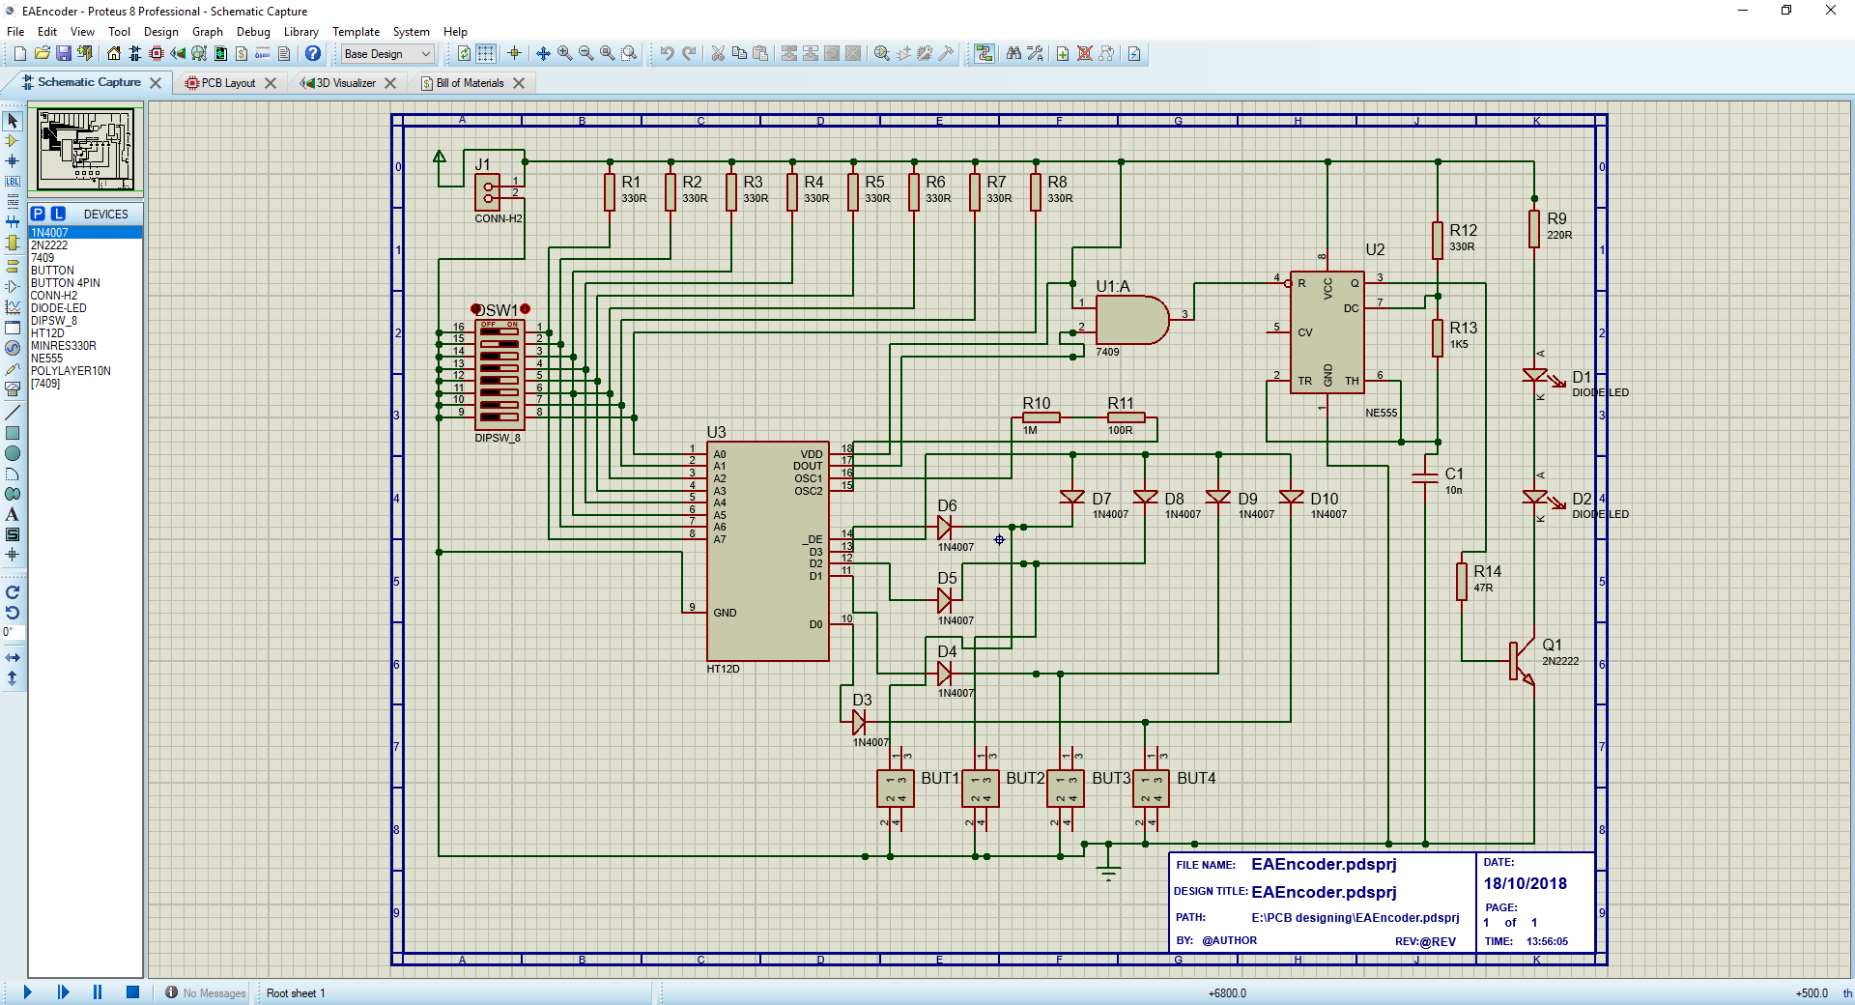

The PCB was designed by selecting the *PCB layout* icon in the taskbar. This created a new tab within the project that would be used to create and design the new PCB layout.

Firstly, I needed to change the design rules in the Design Rules Manager in the toolbar. With this tool I could change the placement of the tracks on any layer of the PCB, but for this task I had opted to place the tracks on the bottom of the PCB. The rules also allow you to change the thickness of the tracks by altering the trace style, neck style and via style.

After doing this, I then needed to draw a layout for the shape of the PCB. I do this by selecting the boarder edge tool and changing the colour of the lines to ‘boarder edge’, which is a yellow colour. After drawing out a rectangle with this tool, I can then select the properties of the rectangle and change the width and height of the rectangle. I had set the width and height of the rectangle to a size of 90mm width and 50mm height. I then applied the changes.

After doing this, I was able to then click on the *auto place component* button, which will automatically place all the components from the design layout and place a footprint of that component in the PCB environment, inside the area of the drawn rectangle.

From this, I can arrange the components in a logical way where all the connections can be made. Once the components have been placed in the way that I think is reasonable, I can press the *auto route* button in the toolbar. This button will make Proteus calculate all the possible connections that it can make by following my schematic, without crossing any of the tracks. After the program makes the connections for you that it can, it will leave any connections that it could not make. The way that I fixed this was by deleting tracks that was in the way of other tracks that needed to pass through and redraw them using the *track mode*, until I can make a connection to all the possible terminal connections in my design schematic.

Encoder

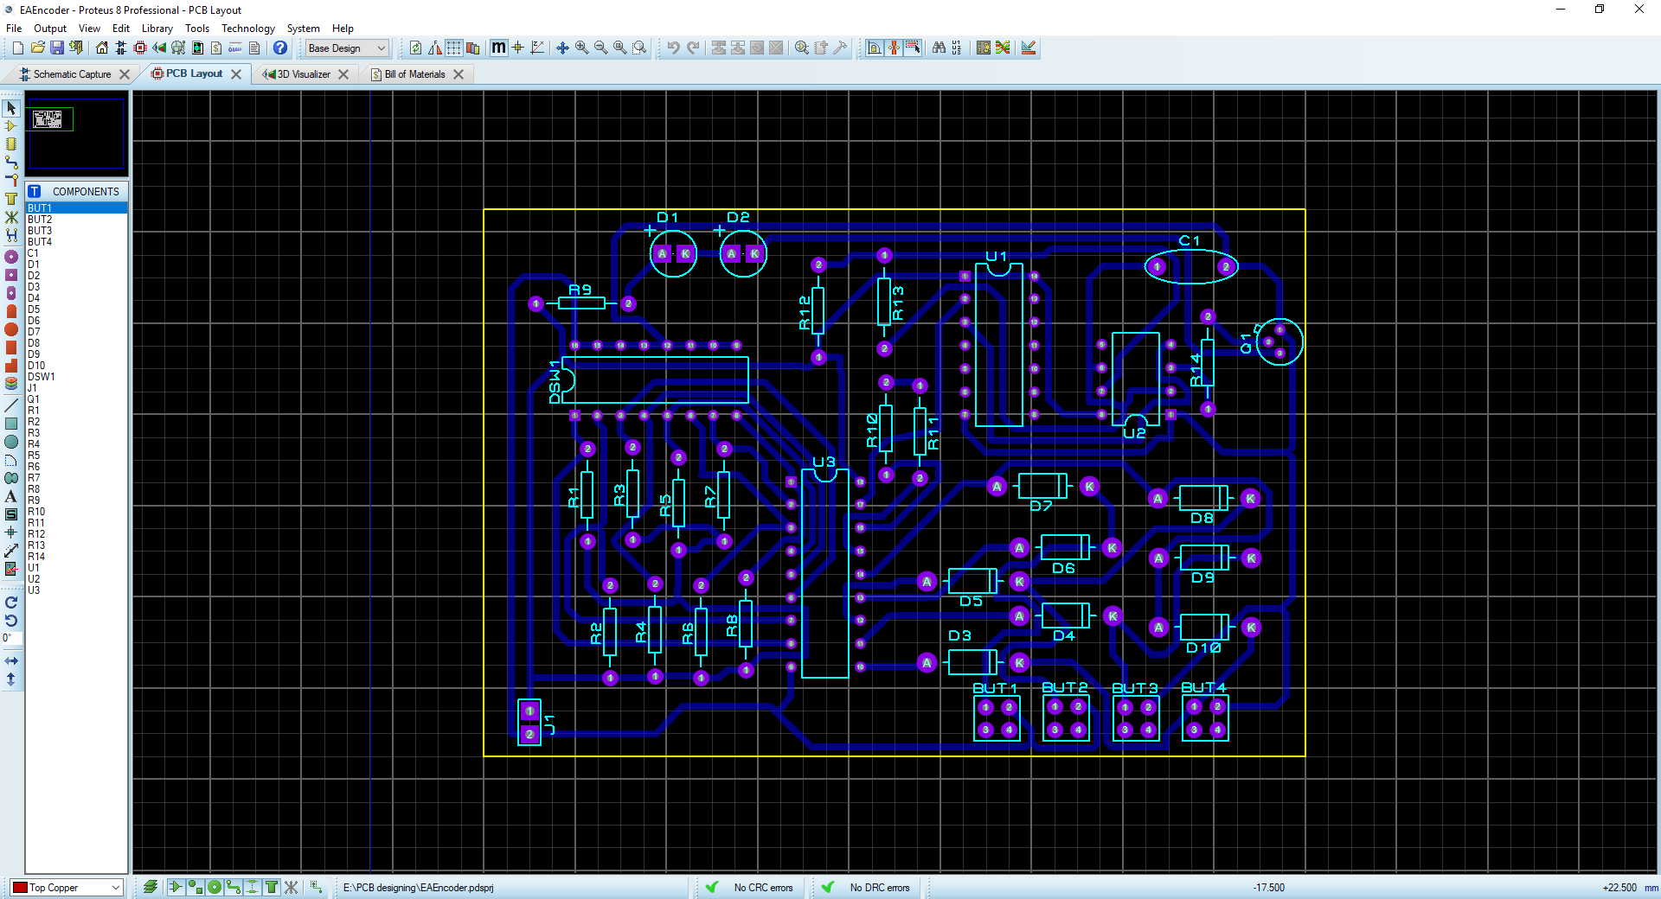

Decoder

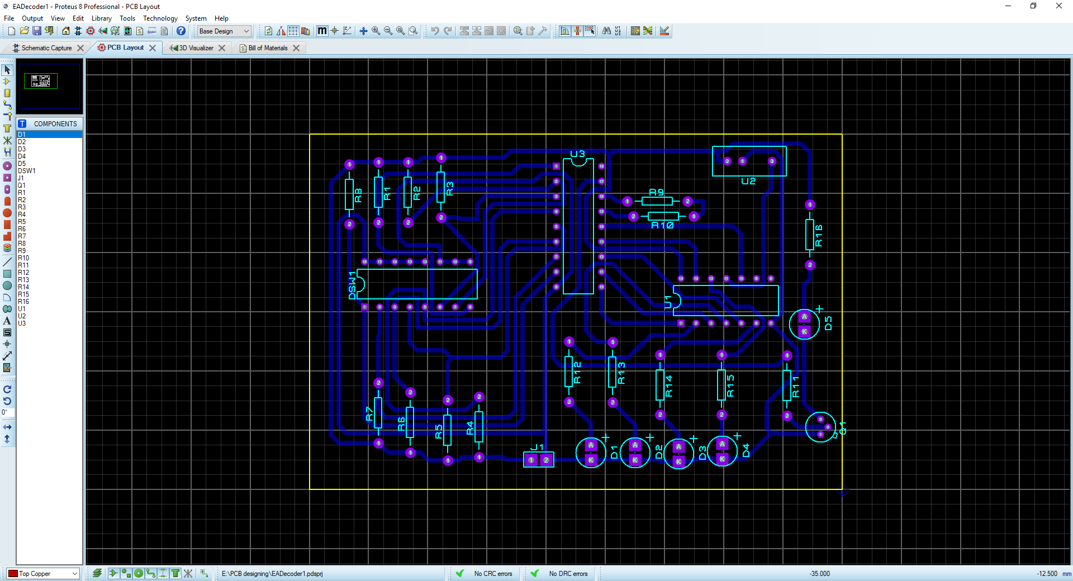

In the images shown above, I have used the Proteus software to render both PCB circuits as a 3D model. This feature allows me to observe the PCB in a 3D environment before the circuit board gets printed. This is done, so I’m able to see the PCB with all the components installed and soldered. The 3D render of the PCB also shows the details of the resistor components, displaying the colour bands of each resistor with the correct value. It will also help to display the correct orientation and polarity for each LED, diode and transistor; including any other component that is not commonly used. This 3D model is an accurate representation of the printed circuit board when it was printed and soldered. The 3D model however, doesn’t display the code for the ICs that are rendered in the 3D environment, so it will not reference you to a specific type of IC with its identification code.

# Component spec: -

When I finished the designing process for the schematic and the PCB, I would then need to be able to create a list of components called a BOM (bill of materials). There is a button in the toolbar that allows me to make a spreadsheet of components, that I need to build the circuit constructed in Proteus. I’m able to edit the spreadsheet, allowing me to be able to add a stock ID and a pricing of the specific component. This BOM can then be printed off and sent to the technicians so they can order the components for me, once I have ensured that all my designs have been looked over to see that there are no mistakes.

Decoder

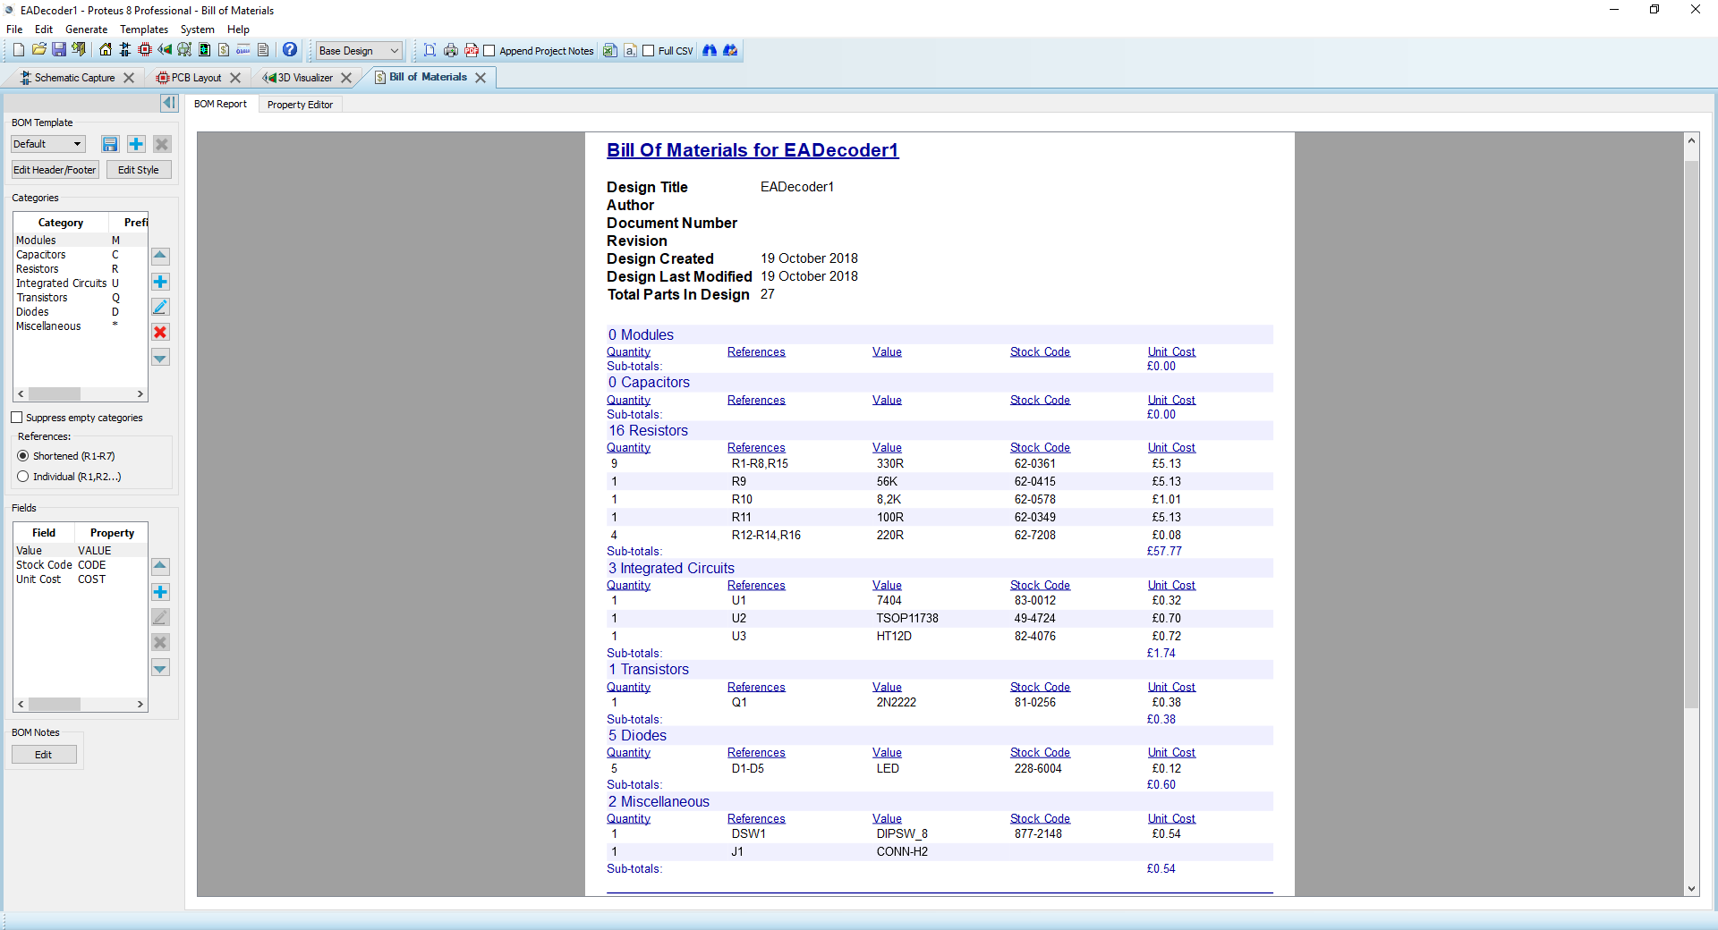

Encoder

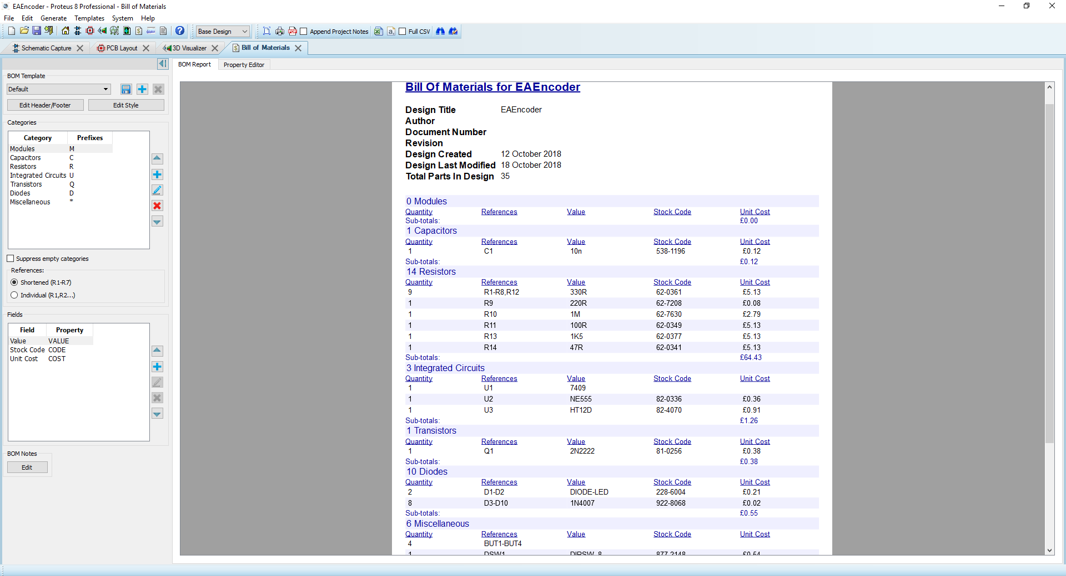

To order the components, I had to print off the Bill of Materials and talk to one of the technicians about ordering these for me. Or that would be what I would do in the future, because the university already supplied the materials to us. However, if we needed to order multiple parts from different suppliers, I would need to make multiple BOM’s for each supplier that I request an order from. Giving these different lists to the technicians, so they can put through the order for me. The university has a history with ordering components from RS in the past, so I had decided to order from them thinking that the university would be familiar with the website, the company and the process of ordering. For the collection of components, I had used the RS website to find all the components that I required. Copy and pasted the stock ID and price into the spreadsheet, ready for printing.

# Build: -

Before I attempted to use the soldering kit to solder the PCB boards, I had to follow these simple safety precautions beforehand. To start with, I had to pick a workstation and collect the tools bag from the end of the class; leaving my ID card as an exchange, retrieving it when I return the tool set at the end of the lesson. After collecting the tool set and setting it down at my station, including a pair of safety glasses, I can now inspect the cable of the soldering iron to make sure that the insulation hasn’t been damaged in any way. This is because I wouldn’t want to give myself an electric shock from touching an exposed cable. I will also need to make sure that I have a functioning extractor fan to extract the fumes that would be given off from the heated solder. I can test the extractor fan by placing my hand above the device to feel any wind being blown upwards. And if there is, then I can conclude that the extractor fan is functioning as expected. Now that I have checked these things, I can now turn on the extractor fan and wear my safety glasses while I solder; making sure to not remove the glasses or turn off the extractor fan unless I have placed the soldering iron back, safely, into the soldering iron stand. I must also prevent myself from breathing in the toxic fumes when looking directly above the circuit board when I am soldering it. I must also keep my face away from the circuit board when I am soldering so the molten solder doesn’t spit any hot liquids into my face and I must also only hold the soldering iron from the handle and not the metal shaft of the device, as this is not a safe place to grip the soldering iron from and will burn the skin on contact. Once I have finished soldering the circuit board or I am not currently at the soldering station, then I must switch off the soldering iron until I return and continue to solder.

What’s important for a good circuit board is some good solder joints to go with it. A good solder joint will have just the right amount of solder applied to the heated pad and component, while also making sure to not add too much heat to the point where the solder pad starts to lift off the board. When this happens, the solder joint has a darker or burnt tone than the regular shiny surface. You must also make sure to clean the tip of the soldering iron first by melting some solder on the tip of the iron and cleaning it off with the iron wool. The types of solder joints to avoid are a cold joint, a short, too much solder, not enough solder or like I’ve mentioned before, applying too much heat to the solder and pad. A cold joint is when the solder of a joint has not cooled down completely and the component has been disturbed during the cooling process. A cold joint will cause the joint to crack, making it prone to snapping and making a break in the circuit.

For the soldering process, I had used a multitude of tools for different applications. One of these tools being the iconic soldering iron, which I have used to heat the soldering pad and melt the solder. When I need to clean the soldering pad I will use the container with the iron wool inside and scrape the dirt off the iron with the iron wool by putting it through the large hole in the container. When I needed to strip some insulation from wire, for example when I was soldering wires together to make a cube and to solder wire to a strip board, I used the wire stripper tool found inside the tool bag. This allowed me to adjust the tool to the specific gauge of the wire, so I wouldn’t damage the metal core while stripping the insulation off the tips. I had also utilised fine tipped pliers to easily bend the legs of the components clean and accurately, so they may fit nicely into the holes of the PCB. I also used an extractor fan to protect me from any dangerous fumes by sucking any fumes through a filter. I had also used a 3D printed wire holder, which holds two wires that I am trying to solder together. I applied this tool when I was soldering my cube.

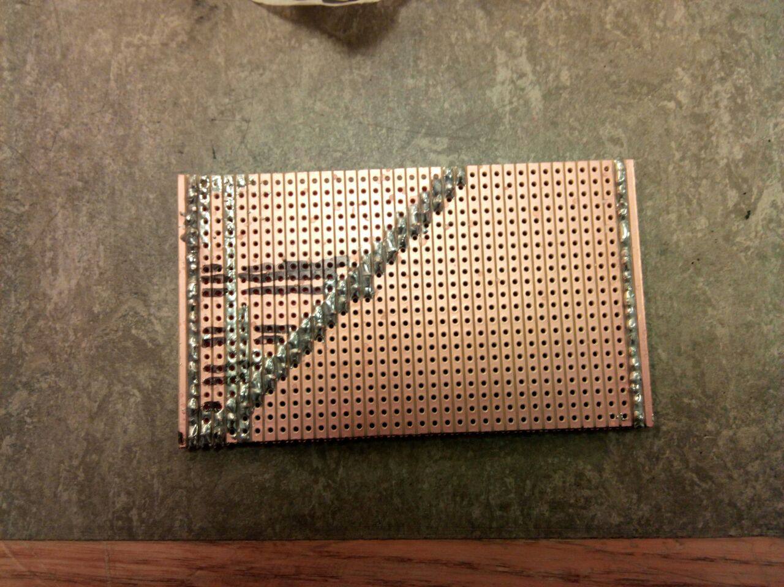

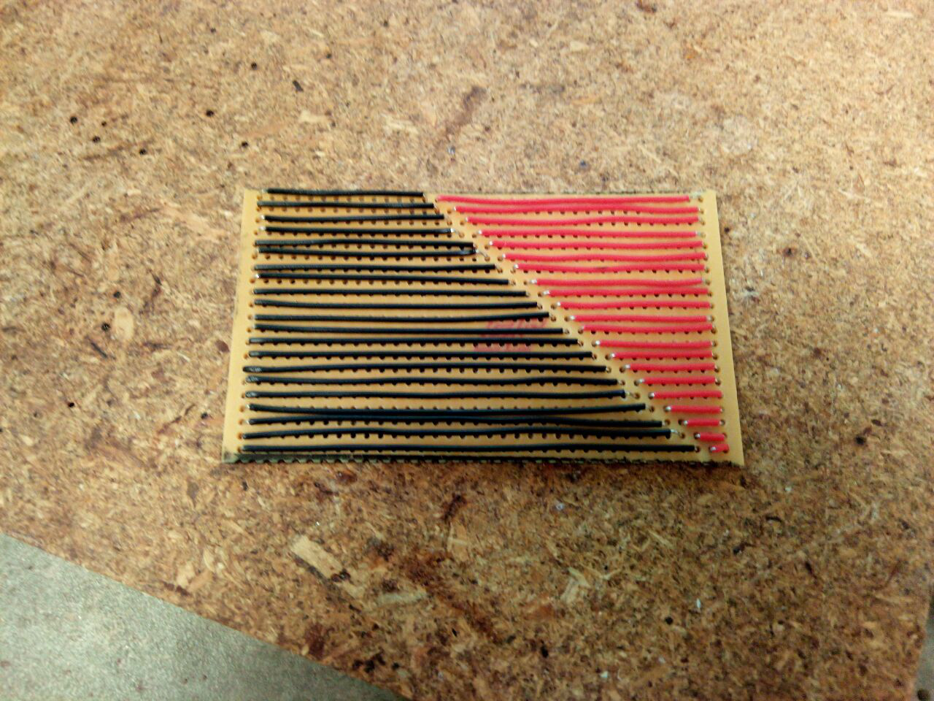

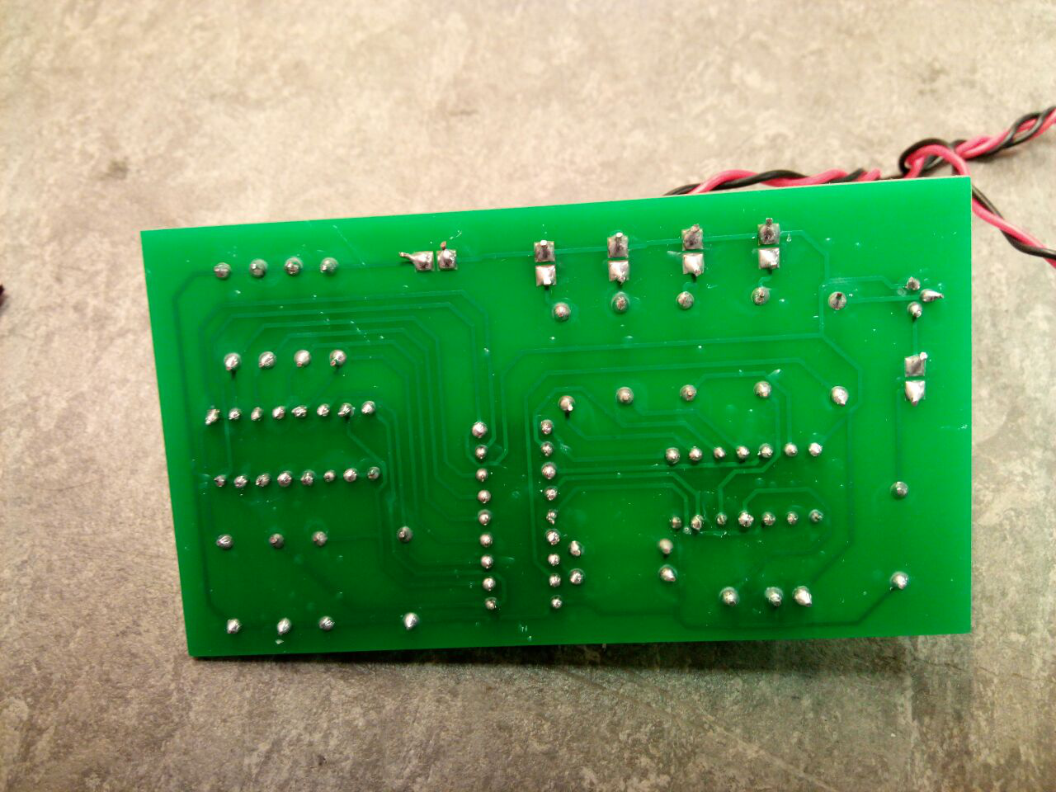

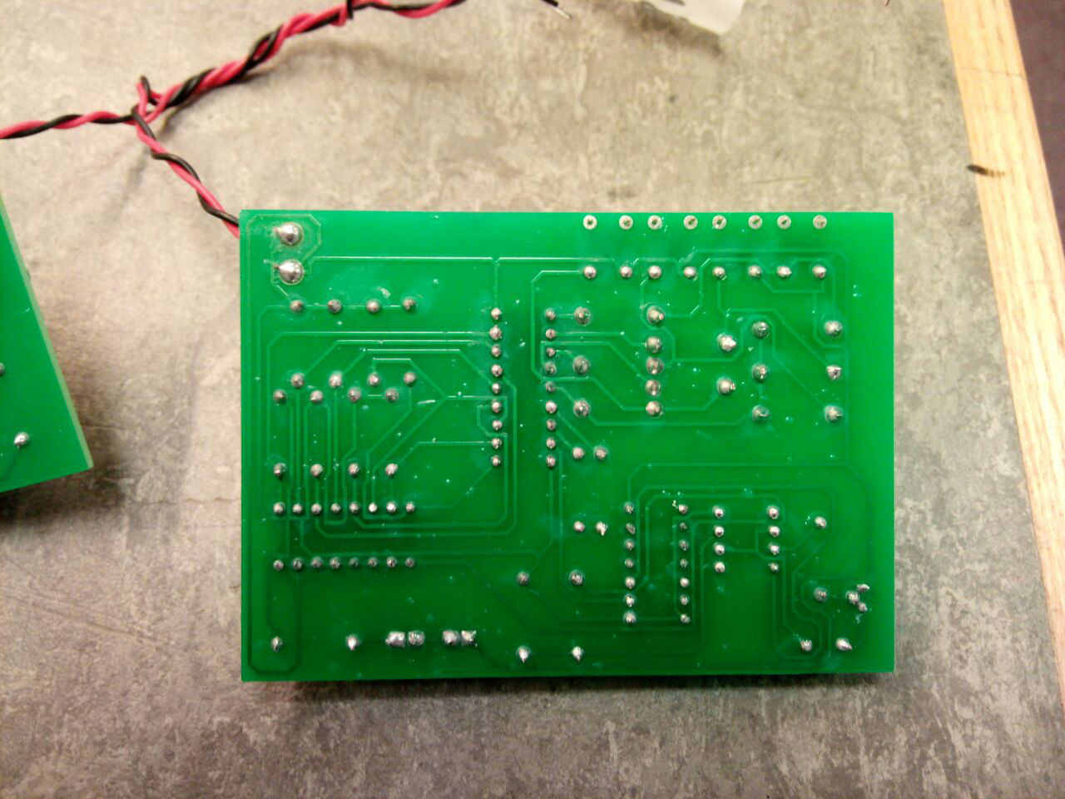

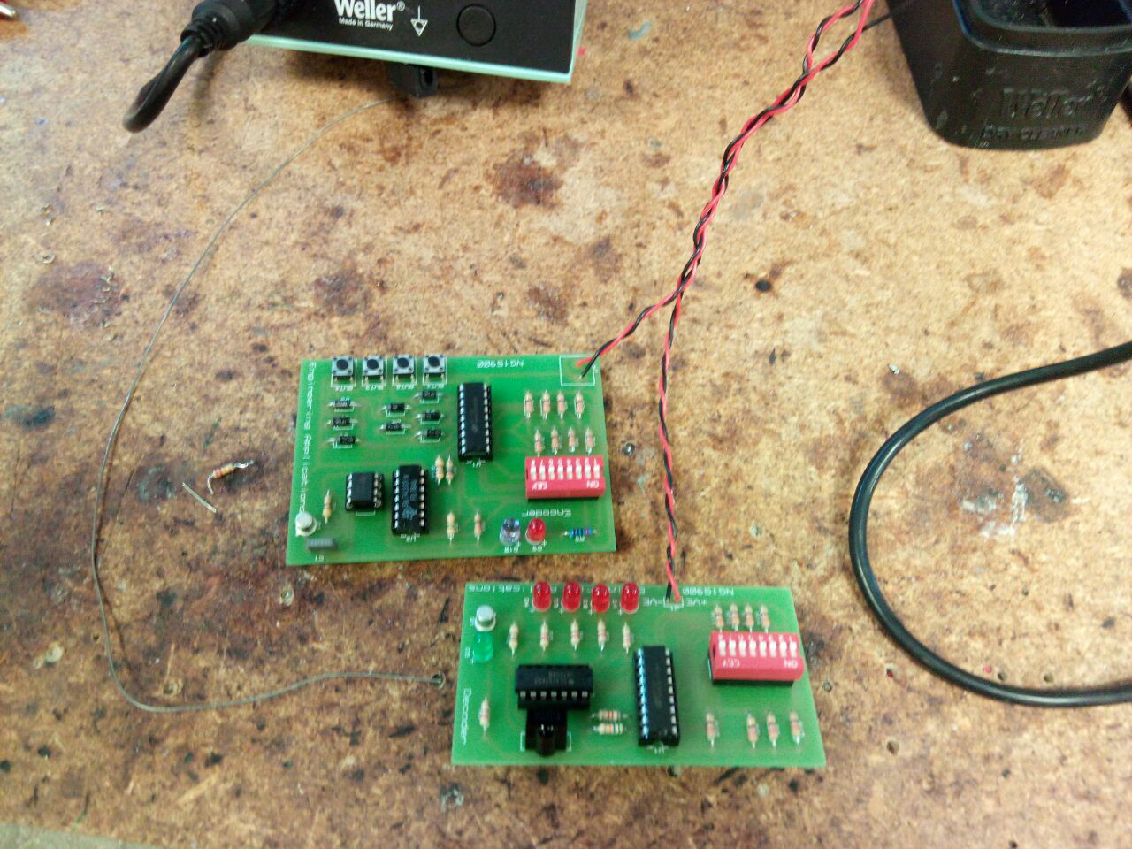

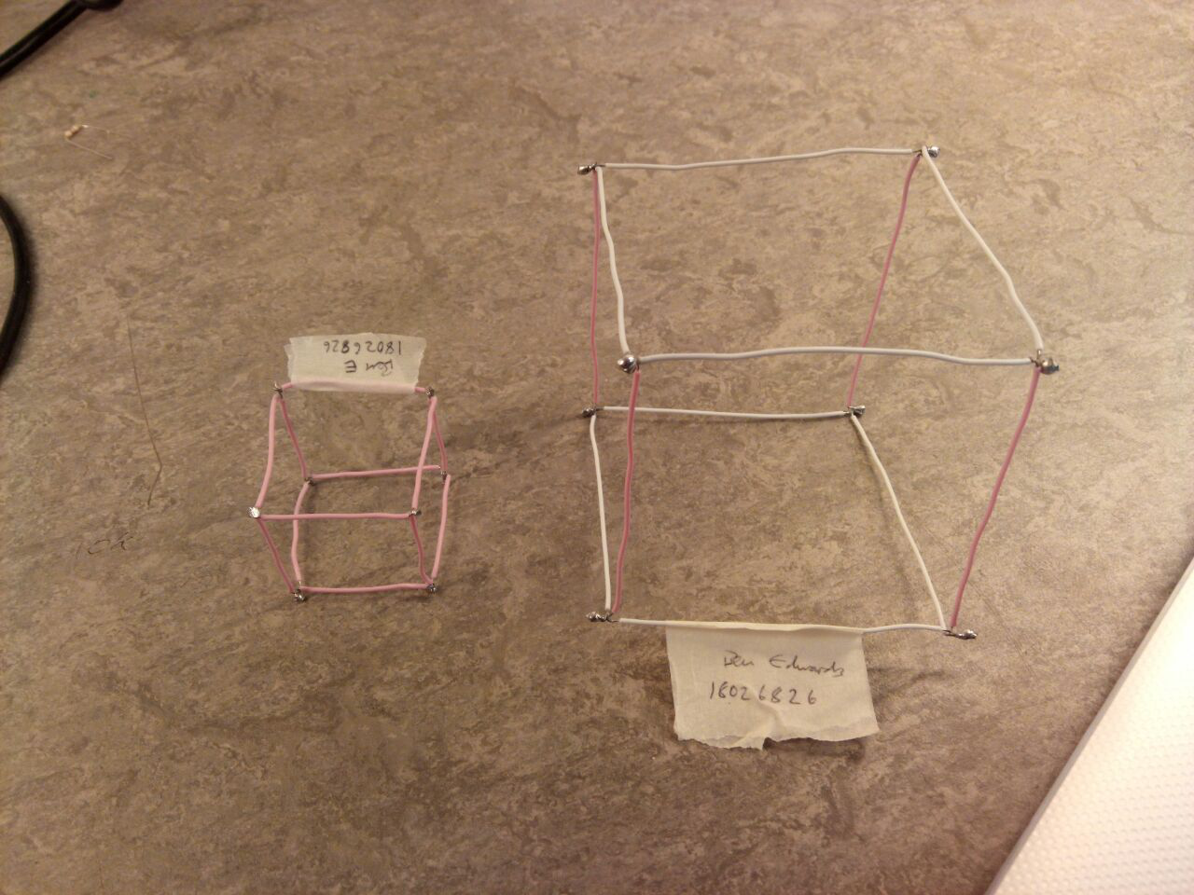

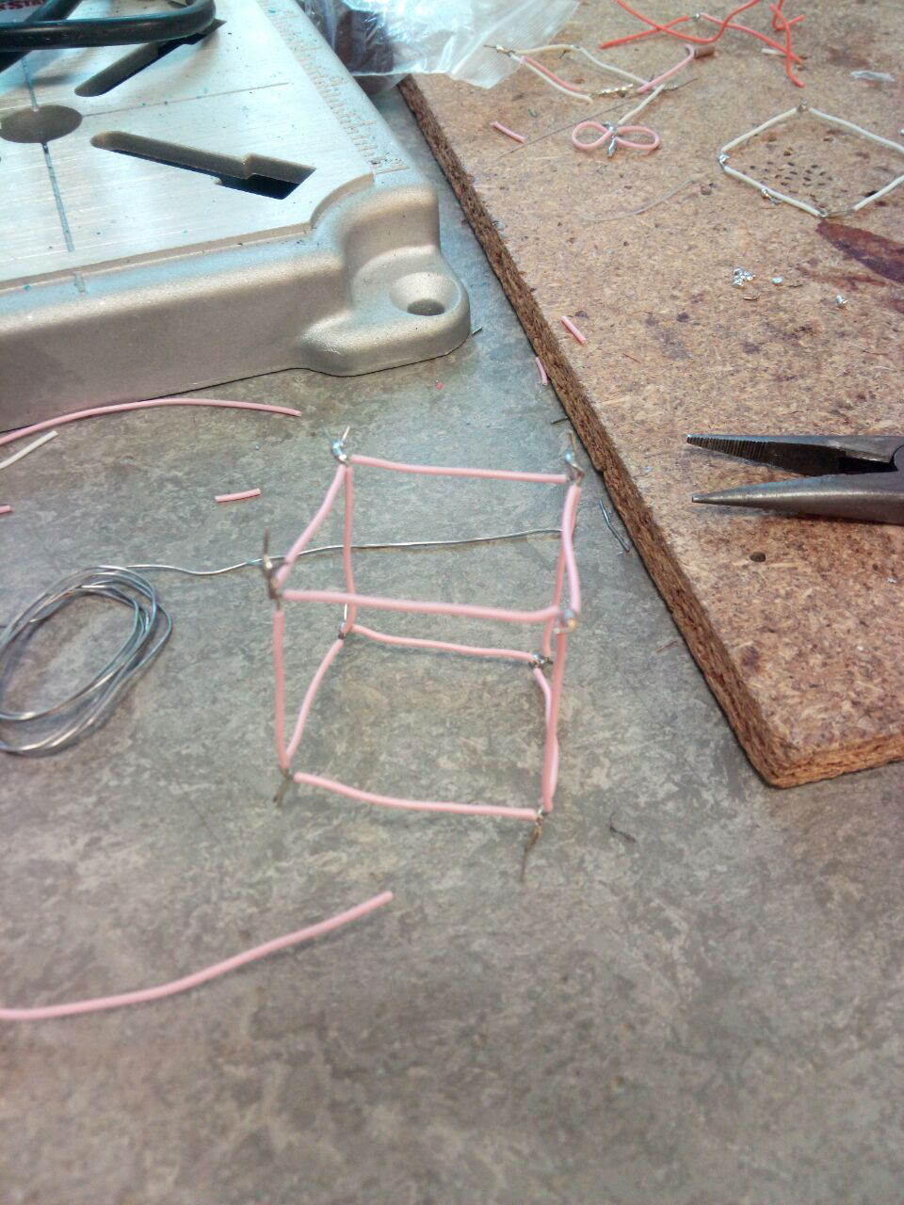

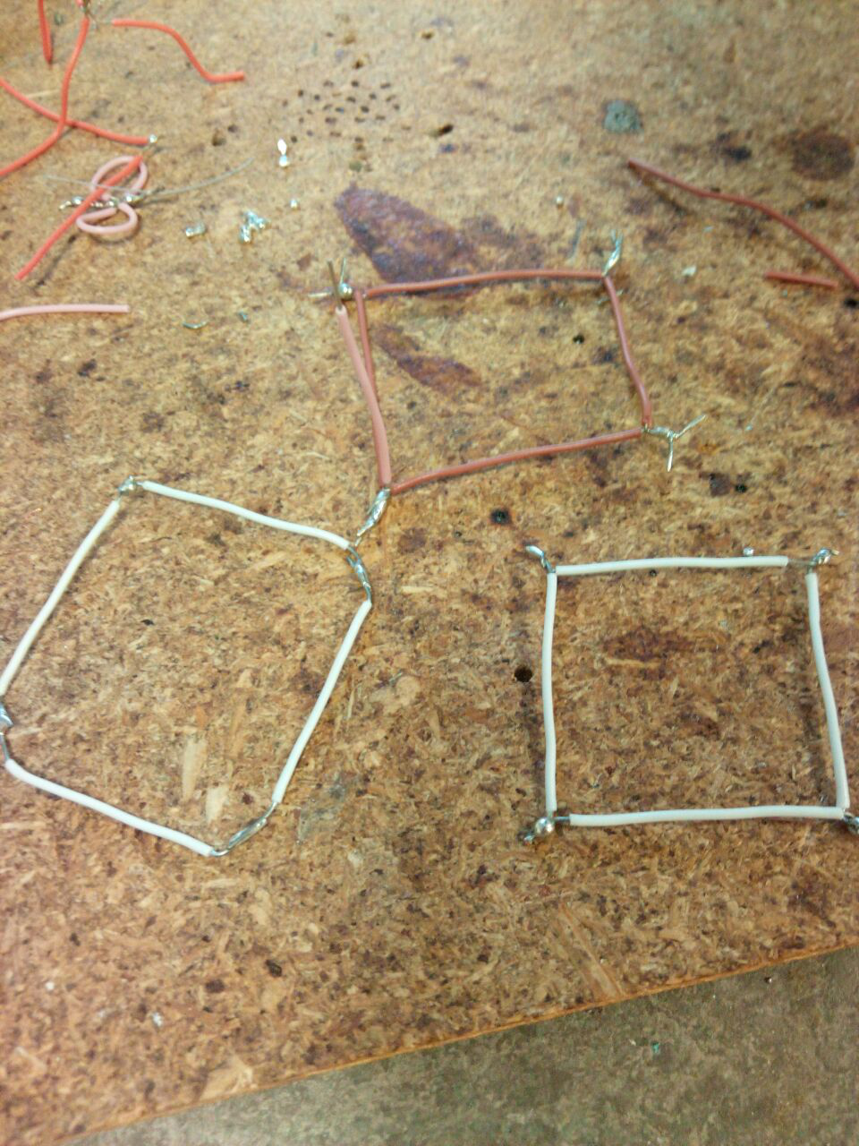

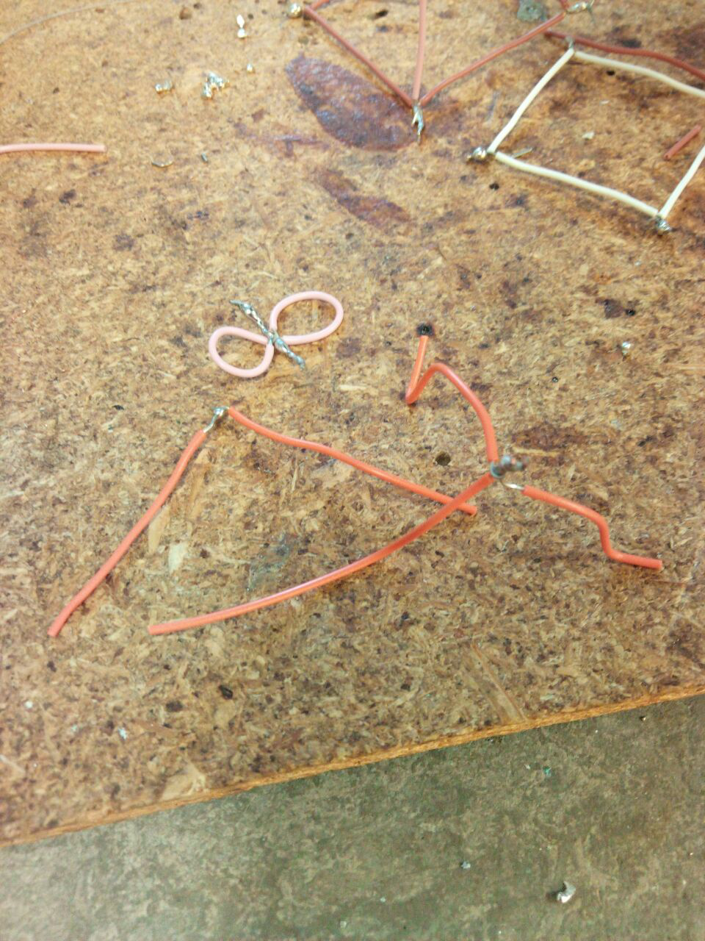

The cube

* To construct the cube, I had to first remove the insulation from the number of wires that I would need for this, with all the wires the same length as each other.
* After I had done that, then I would need to place all the wires in a ladder arrangement.
* I will first select three pieces of wire and tin both sides of the exposed core. To improve the take of the solder. This will improve the quality of my solder joint.
* I would then use the 3D printed jig to solder three of the wires together by twisting the three exposed wire cores.
* After doing that, I can then straighten out the wires and prepare the next set of wires for soldering
* I continue this process until I have completed the construction of the ladder.
* After this I can then bend each joint 90 degrees so that the last exposed wire tip can reach the first two clean solder joints that was made.
* I would then use the pliers to wrap the wire core around the soldered joint, before then applying more solder so that there is a good, strong bond.

The strip board

* First, I measured the length of the wire in comparison to the distance of the holes, then cut the wire with a lot of extra wire.
* I stripped one side of the wire and then stripped the other side but trying to make the insulation short enough so that the wire would be flush to the board when it has been soldered to it.
* I would then clean the soldering iron by wetting it with solder and scrapping the solder away in the iron wool, so I can then make a clean soldering joint.
* I then wet the wire core of the wire with solder without melting the insulation.
* After that, I soldered the wire to the board without melting the insulation, trying not to create a cold joint or a burned joint.
* I would then repeat the process by soldering a wire one space below and increasing the size of the wire by one space or through hole.
* Once I had done that, I could then repeat the process on the other side of the board, leaving one space between the two sides.

The Encoder and Decoder

* First, I had to collect the components that was on the list required for the PCB boards.
* I would then place them in the correct through holes of the PCB, while checking the polarity and the values of the components.
* Once I have inspected each component to make sure that they are correct, then I will then start to solder each component to the board
* Before I start to solder the components. I must first wet the tip of the iron once again with solder and scrape the solder off with the iron wool to clean the tip.
* I can then place the circuit board upside down and solder the resistors in first because the resistors are the same size and the won’t fall out of the holes because of any different height differences.
* I can then Solder the diodes to the PCB board, making sure to check the polarity of the diode indicated by a thick grey line on the one side, marking the cathode. I would match up this thick line with the markings on the PCB.
* I would then solder in the LEDs, checking the legs and the inside of the LED, to see which the negative leg was. And that is the shorter leg, or the positive leg would be the leg connected to the larger plate inside the LED.
* I soldered the DIL slots by soldering each corner leg first with a reasonable amount of solder to hold them in place, so they wouldn’t become disturbed and create a cold joint for any of the other legs.
* I could then solder in the rest of the components with ease and solder in the black and red power supply wires.
* I can then repeat the process for the second PCB board.

Decoder

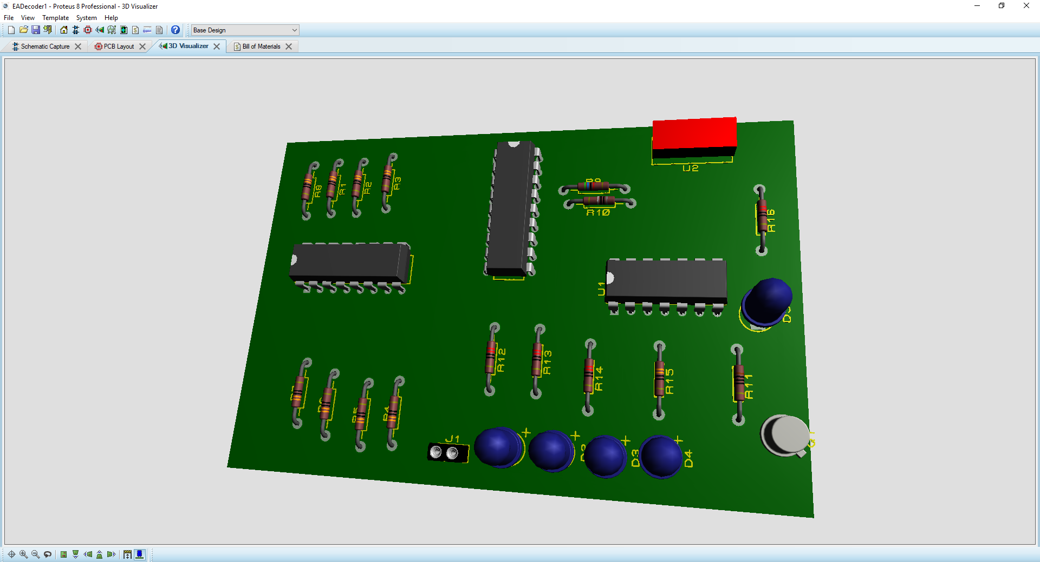

Encoder

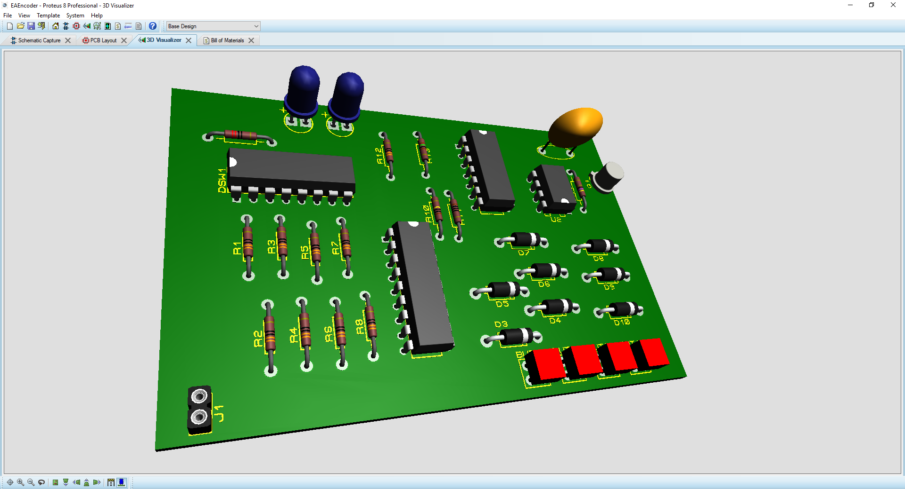

Comparing my PCBs to the 3D rendering of the Encoder and Decoder, I can say that they look very similar. However, there is a difference between the two, and that is the fact that the PCB that I built is more accurate than the 3D rendition because the 3D version is missing the models for other types of components. For example, the DIL switches and the buttons. The 3D version can also show us the perfect solder joints that I should have been aiming for. From looking at the two, I can say that I have not been able to achieve the prefect solder joints, but they are however good solder joints that will last.

# Test: -

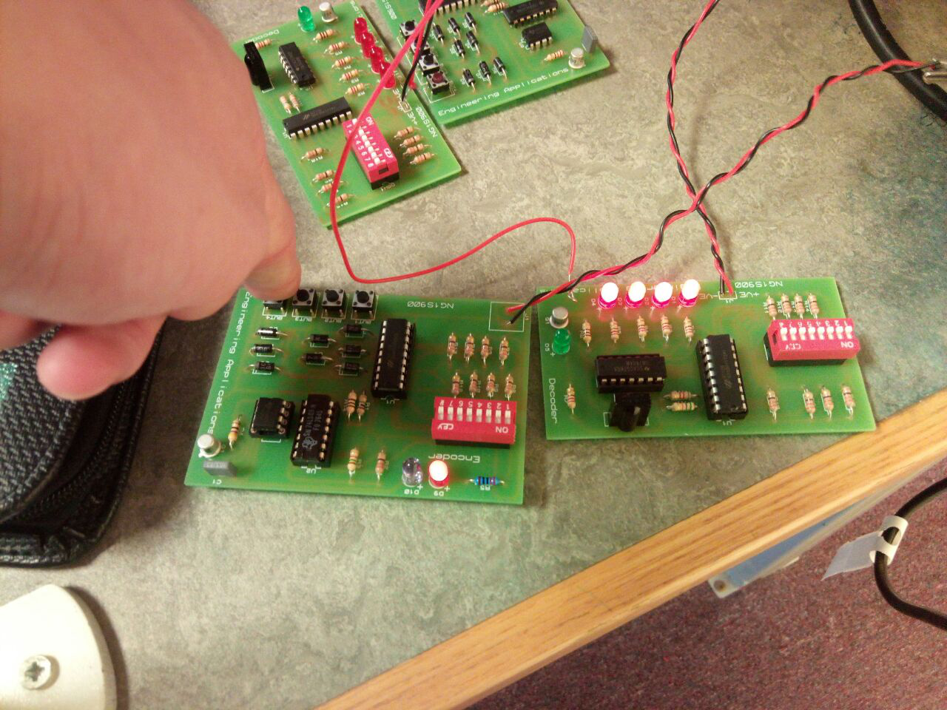

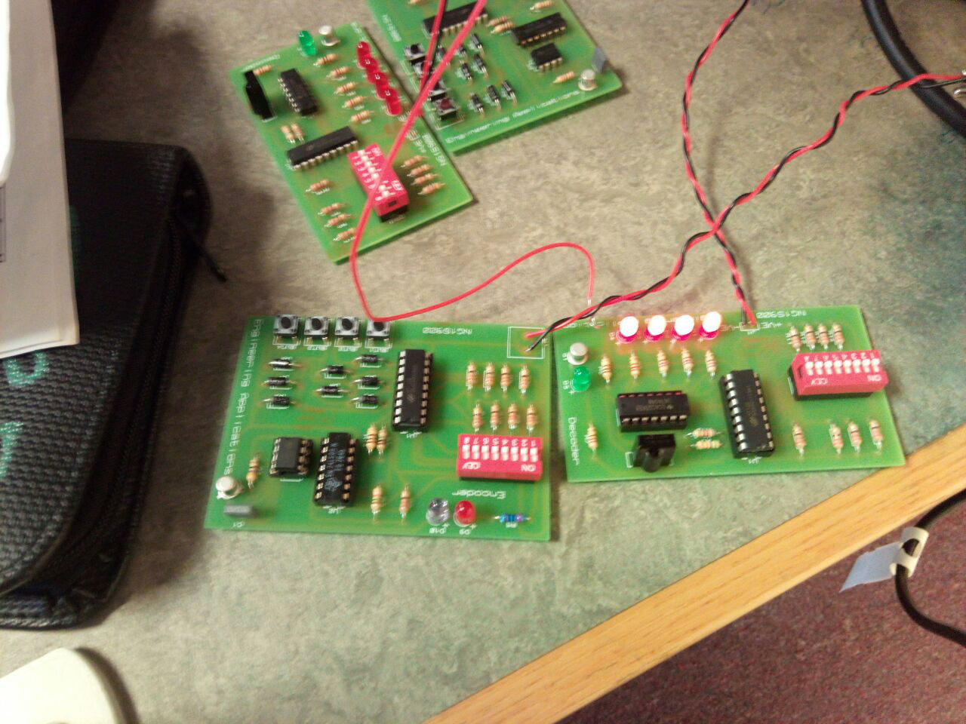

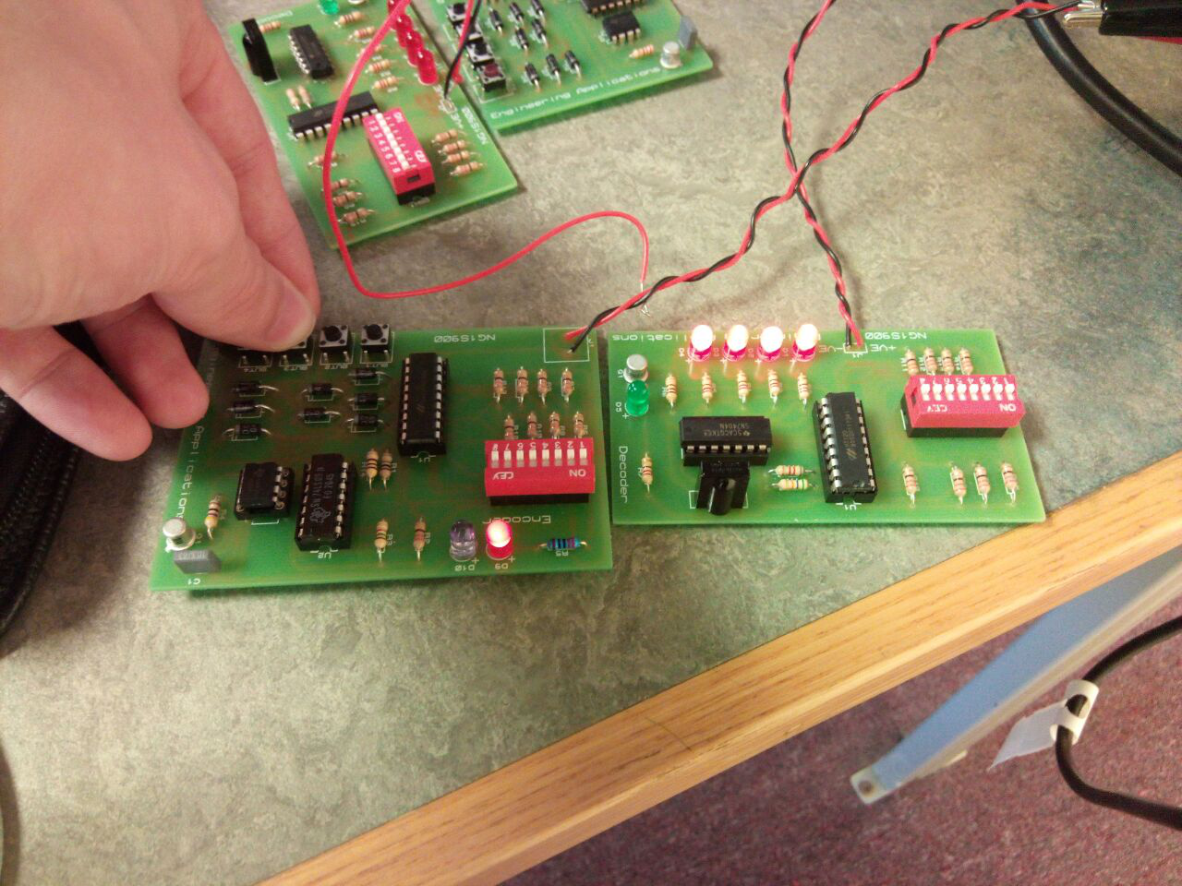

For the testing process, I had used an external, variable power supply and set the voltage and current for both supply outputs to 5V and 0.01mA. The power supply takes the mains supply and converts it to a value that has been input by the user, which is done by tuning voltage and current nobs, with the value being displayed on an LCD screen. I then connected both circuits to the power supply with these same values. Now that the circuit boards were powered, could then begin to test the circuits and see if they affect each other, by pressing a button on the Encoder. Seeing if the red LED turns on, and if all the red LEDs turn on, on the Decoder circuit. By seeing that the red LEDs on the Decoder circuit have a positive charge across it and light up, I can conclude that the IR LED on the Encoder and the TSOP is picking up the IR signal from the IR LED. If I ever saw that the draw current, being displayed on the power supply, gets up to around 0.1mA, then I will know that there is an error in my circuit that I will have to review.

# Conclusion: -

During the testing of my circuit, I can conclude that the current never exceeded 0.1A and sat at around 0.01mA for both circuits, while being powered by a 5V supply. I could also see that the red and IR LED on the Encoder was being powered and sending a signal to the 4 red LEDs on the Decoder PCB. From this I could conclude that my circuit was successfully working as intended, the Encoder was transmitting an IR signal which the Decoder TSOP would then be able to pick up, so the circuit board didn’t need to be reviewed. I had found this Task difficult when it came to design the circuit in Proteus. I had no prior experience with Proteus, so designing the PCB was a struggle for me as I was unfamiliar with the PCB designing software side of the program. However, I did get around to understanding the system eventually and could design another circuit using Proteus with ease in future. I had found the soldering side of the project familiar as I prior experience before starting this course. I have learnt how to create better soldering joints with my experiments with the soldered cube, developing a technique that works for me. I was also able to learn how to design circuits and PCBs using Proteus and how to create a Bill of Materials to order the components that I would need. Next time I would improve my PCB design by trying to compact the components closer together, requiring less material to construct the PCB board itself.

By Ben Edwards

Student ID: 18026826